Hi and welcome to my game narrative design portfolio. The following example of narrative design elements features a fictional dystopian RPG action/adventure, detective game with elements of horror.

Ideally to be played on the following platforms: Playstation, Xbox, PC.
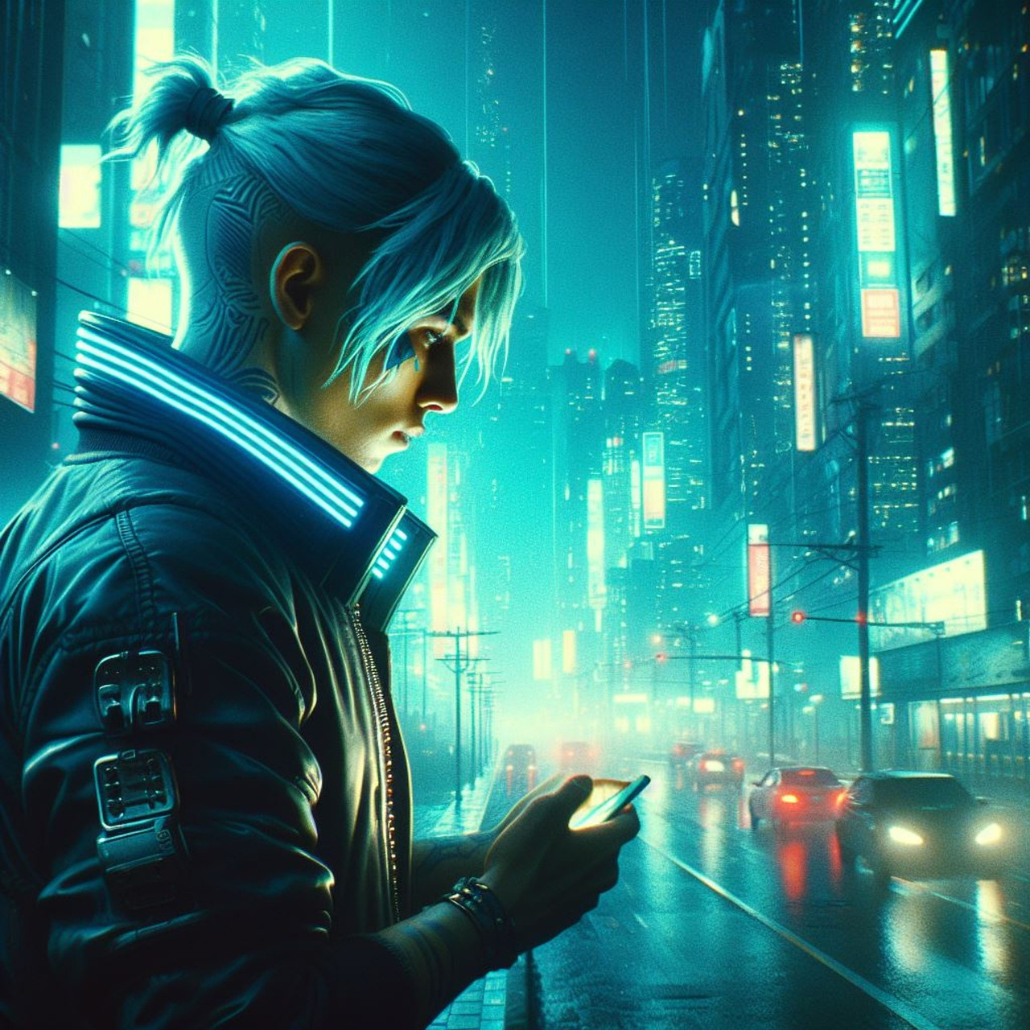

Game - a single-player RPG set in futuristic, post-apocalyptic Tokyo.

Assume the role of a Tokyo Police rookie detective, Mizako, who is assigned to investigate a series of mysterious deaths, alongside his jaded, foul-mouthed, ‘been there done that’ senior partner, Rohei.

Character Bio / MIZAKO
Name: Mizako
Age: 29
Occupation: Rookie detective in Tokyo homicide Unit

Mizako grew up with his sister, Hoshi, in rural Japan, away from the hustle and bustle of the city. Their parents were busy running a local noodle joint, which meant the children were frequently left to their own devices. Being left to do what they please would result in one thing, and one thing only - getting up to no good. During one of such shenanigans, Hoshi fell into a well and, tragically, drowned. Mizako blamed himself for being careless and unable to find his sister in time, which, in part, led to his becoming a detective later on.
His parents never recovered and, as soon as Mizako was old enough, sent him off to Tokyo to figure things out on his own. This is where Mizako spent a large portion of his adult life and it’s a wonder he didn’t get chewed up and spat out by the ruthless jaws of the metropolis.

Traits
Appearance: a peculiar case of ‘don’t judge a book by its cover’
- Tattooed
- Athletic
- Hates suits, has own style consisting of a bomber jacket, cargo pants and his signature accessory - beat-up, combat boots
- Clean-shaven, hair - short-ish, but long enough to put in a mini bun, sometimes sporting an undercut

Intelligence: very intelligent but doesn’t necessarily let on
Qualities: polite, empathetic, debonair, meticulous, tech-savvy
Flaws: unsure of himself, inexperienced, too compliant, by the book, afraid to mess up
Wants: to become a badass, erudite detective just like his seasoned partner
Needs: to come into his own, trust his gut, break out of his mind-forged shackles
Nervous ticks/ other: tends to zone out ( check out ) a lot when thinking things

Voiceprint:
Mizako is soft-spoken, debonair, empathetic, considerate, and mischievous at times.
Mizako is not cocky, judgemental, mean or cowardly.

Themes
Loyalty, power, generational differences, empathy, betrayal, vengeance, forgiveness

Background
Mizako has been working as a police officer in the Tokyo Homicide Unit for a couple of years now, and has recently been made a rookie detective - a title he is particularly proud of. Other than the title, however, Mizako is still very green and, if anything, looks and acts more like a pharmacist - too polite, always happy to oblige, very pc and by the book.
A couple of years ago he was assisting a mysterious, but macabre case that, ultimately, wound up in a Cold Cases Department. The case revolved around a dead child, found in a pristine condition apart from a barely noticeable injection mark on her neck. Mizako was just a junior officer then and was deeply affected by the sheer wickedness of the crime.

Inciting Incident

The inciting incident happens when Mizako takes on his first homicide case, and quickly realizes the case has the exact same mo to the one from years ago. He is forced to undergo
a transformation or several, which help him realize that ethically correct does not always mean morally justified, in other words, life is never by the book.
Luckily, he’s paired with a veteran detective to show him the ropes. What he’s not aware of, however, is that his partner holds a secret and a deep-seated desire for vendetta.

Sample dialogue (crime scene)
Mizako is currently hovering above an empty ashtray, seemingly zoning out again as if connecting invisible dots. The room is badly lit, dirty, and yet, surprisingly nothing seems to be out of place..
Rohei steps over the body splayed face down to take a closer look.

ROHEI
(looking up at Mizako)

Quit looking at that bloody ashtray. You waiting for a Genie to come out?

MIZAKO
(immediately straightening up and joining Rohei)

No, but what if we miss something?
ROHEI

Let CSI handle that. Tell me what you see.
MIZAKO
(clearing his throat)
Well.. umm...I see a body...
ROHEI
(rolling his eyes)

Good. And?
MIZAKO

It's a male. Approximately in his 40s and...it's still fresh.
I mean, he appears to have recently passed.
ROHEI
(amused)
'Passed'. More like offed out of his existence, like a dog.
MIZAKO
Doesn't he deserve even an ounce of dignity?
ROHEI
There's no dignity in death. By the looks of it, I don't think he had any in life either.
MIZAKO
With all due respect, sir...
ROHEI
(interrupting)

Psst! Let me stop you right there, there will be no sir anything. Just call me Rohei.
MIZAKO

Okay, Rohei. I get it. You've been around the block too many times, and must've seen and heard it all.
But...every human being deserves respect.
ROHEI

Oh, for fuck's sake, Mizako! Don't tell me you're one of those 'overly concerned' citizens.
What is it with you youngsters nowadays? All these sappy feelings for everything. Jesus.
Listen, all I know is, you live like, you die like. It's not something they teach you at the academy. You live long enough, you know better.
Somebody who drops dead in a questionable location, under pretty fucking questionable circumstances, I might add, most likely led a questionable lifestyle.

Mizako listens to Rohei's ramblings in silence, deciding to let it go for now.

MIZAKO

So, umm.. We have a witness...of sorts. A lady across the street said she may've seen the...
ROHEI

You mean the whore from Ruby Nights? 'Lady'...hah...
Rohei is left chuckling to himself, as Mizako slowly backs out of the room...eyes widening. He will never get used to Rohei's bluntness, or rather, his lack of basic decorum.
MIZAKO
(sighing)
Anyway, I'll go talk to her.

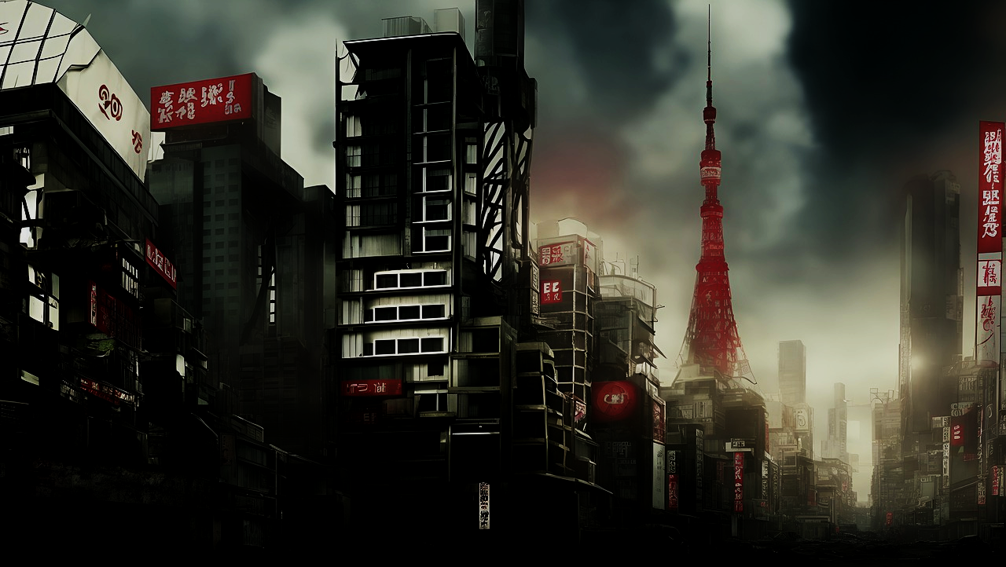
Location Bio
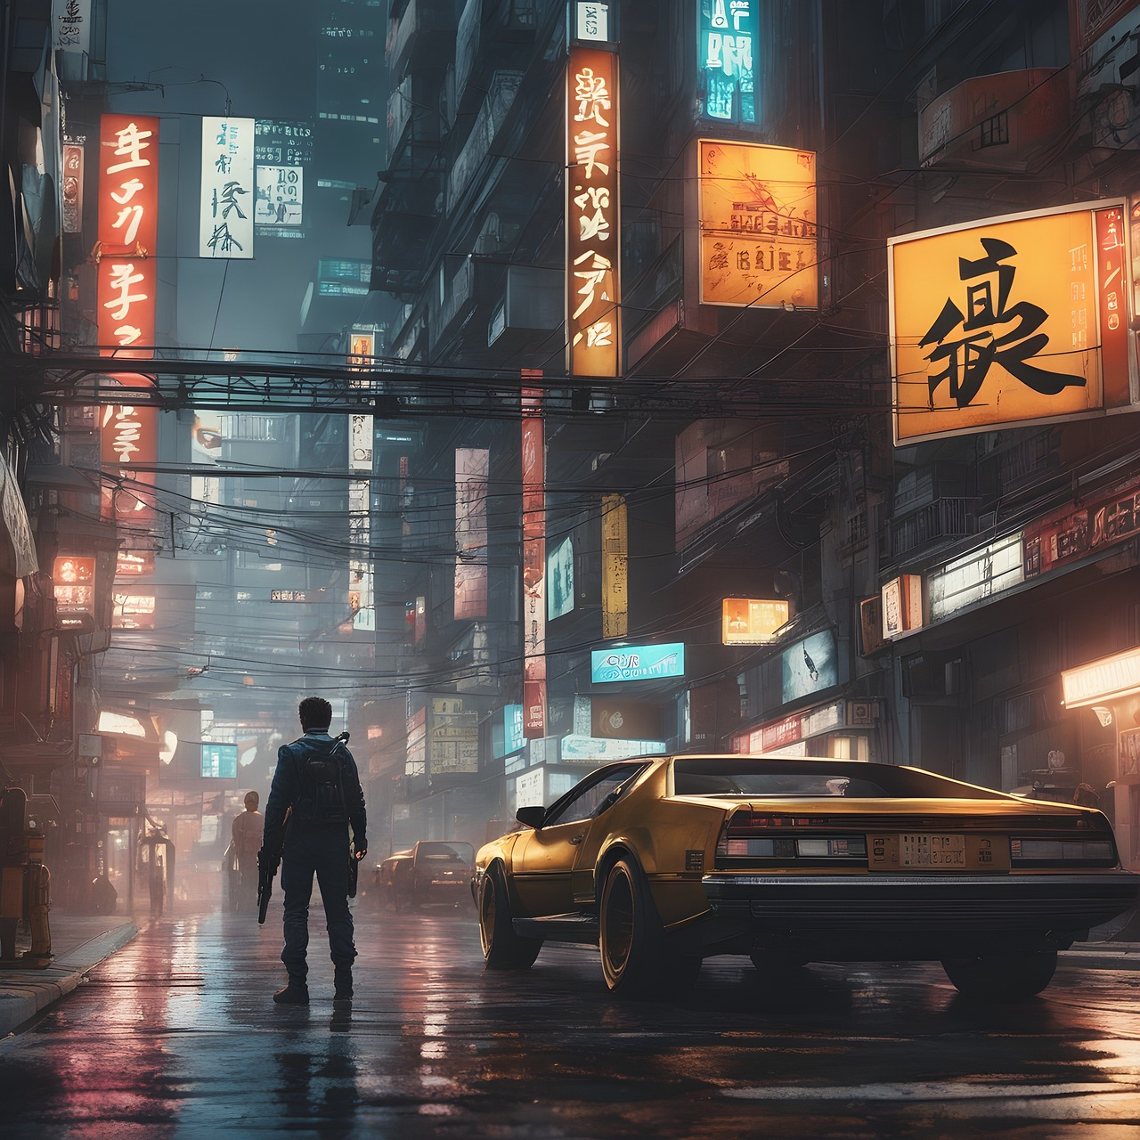
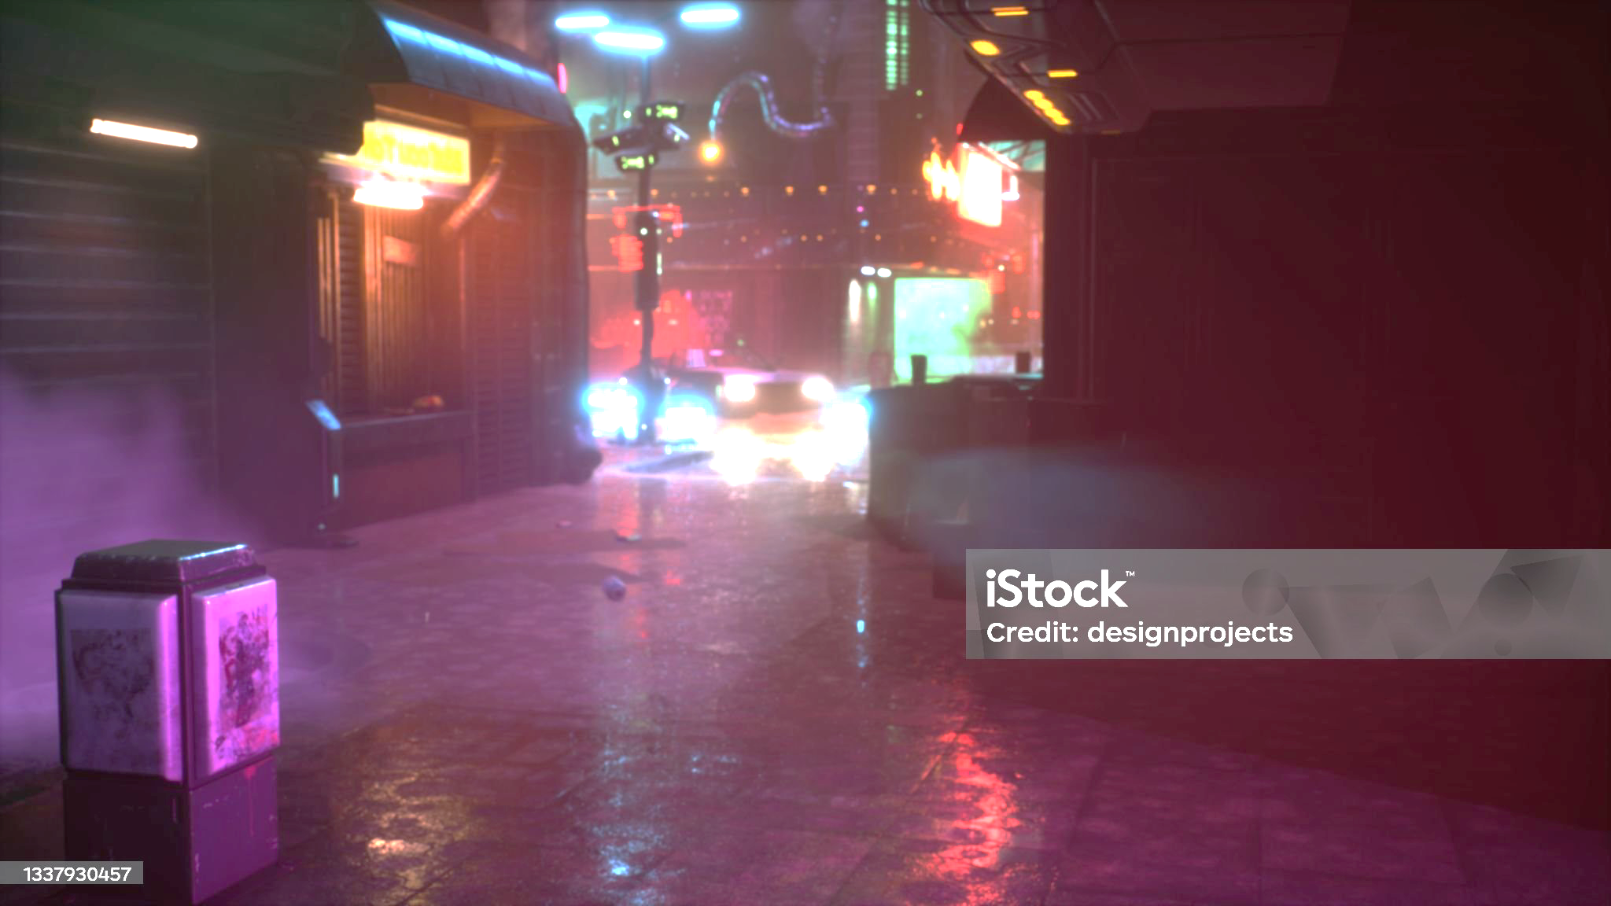

Fictional Location in Tokyo
( area around the Darksuit Enclave )

The pounding rain is ravaging the neon remnants of a once bustling cityscape. Looks like it’s been raining for hours on end. Still, it feels eerily quiet. Evil permeates the air.

An expansive avenue is subtly illuminated by the soft moonlight glow as if acting as a focal point for the main event, only to descend into darkness further away by the looming skeletons of desolate skyscrapers, reclaimed by nature’s inevitable advance.

There, hidden in the shadows is a former, swanky corporate district, which now houses rows of bland, bunker-like dwellings, known as the Darksuit Enclave. Whatever secrets this place holds stay buried beneath the surface, away from the prying eyes. The only exit in and out of the city is kept in pristine condition and lit up
to the teeth - a subtle throwback to bygone days of law and order, in stark contrast to the piles of dismantled, corroded steel scattered nearby. A sheer amount of cameras dominating the road resembles Blackout Violas in full bloom.

The flickering neon lights adorn an endless string of shabby billboards, marquees and signs, all stacked up like pancakes at a non-existent food fair. At the first sign of wind, they break into a melancholic symphony. This kaleidoscope of vibrant colors feels like an attempt at creating a false sense of safety and hope against the backdrop of a drab palette of decay.

Location Bio 2

Bordello / Courtesan’s Secret
( A check-your-brain-at-the-door kinda establishment )

Locals insist it doesn’t exist, it is but a spec on a radar.

A grungy, iron whale of a door sits two steps down from the ground level squeezed between two half-obliterated structures. It makes a ghastly squeak - goosebumps galore. It’s the kind of door which could lead to an illegal drug lab or a money laundering op. The metal is covered in layers of burnt and torn-up ads, some “let’s call it goo” you wouldn't wanna touch with a ten foot pole and god knows what else. A badly lit sign rattles like a leaf overhead. If you’re myopic, you’ll see exactly shit. The message is loud and clear - not for your law-abiding ass!

Do not let that shitty excuse of a door fool you, however. Once inside, it’s like you’ve been transported into an 18th century Victorian French courtisan’s boudoir adorned with Bordeaux red velvet and lace as far as the eye can see. The place is drenched in unhinged opulence. A sea of silk caresses gold-plated settees. Low-hanging candle chandeliers give off a flair of no-holds-barred debauchery and disintegration.

Something resembling a reception desk floating in there somewhere, along with a tiny, burgundy red bell that sits atop. Apparently, the sound of the bell brings all the boys, erm…courtesans to the yard. The services must be mind-blowing.

It’s still a shithole though, silk curtains aside - a pseudo haven for havenots, a prison with nice furniture. If Moulin Rouge and The Shining had a bastard child, this would be it. Rumor has it, there’s at least a dozen, secret underground tunnels underneath with at least one leading out of this god-forsaken city.

Cutscene

"The brief...
Your character wakes up in a room and has no idea how they got there. There is at least one other character in the room, and they are not friends. Yet, they must use
their strengths and weaknesses to escape this strange place."

Cast Of characters

Mizako - a rookie detective who aspires to be a bad-ass detective with a devil-may-care demeanor. Mizako might look the part with his tattooed sleeves and a bad-boy undercut, but, in reality, he's just too green. A freshly baked, cute bun - still uncorrupted and idealistic.

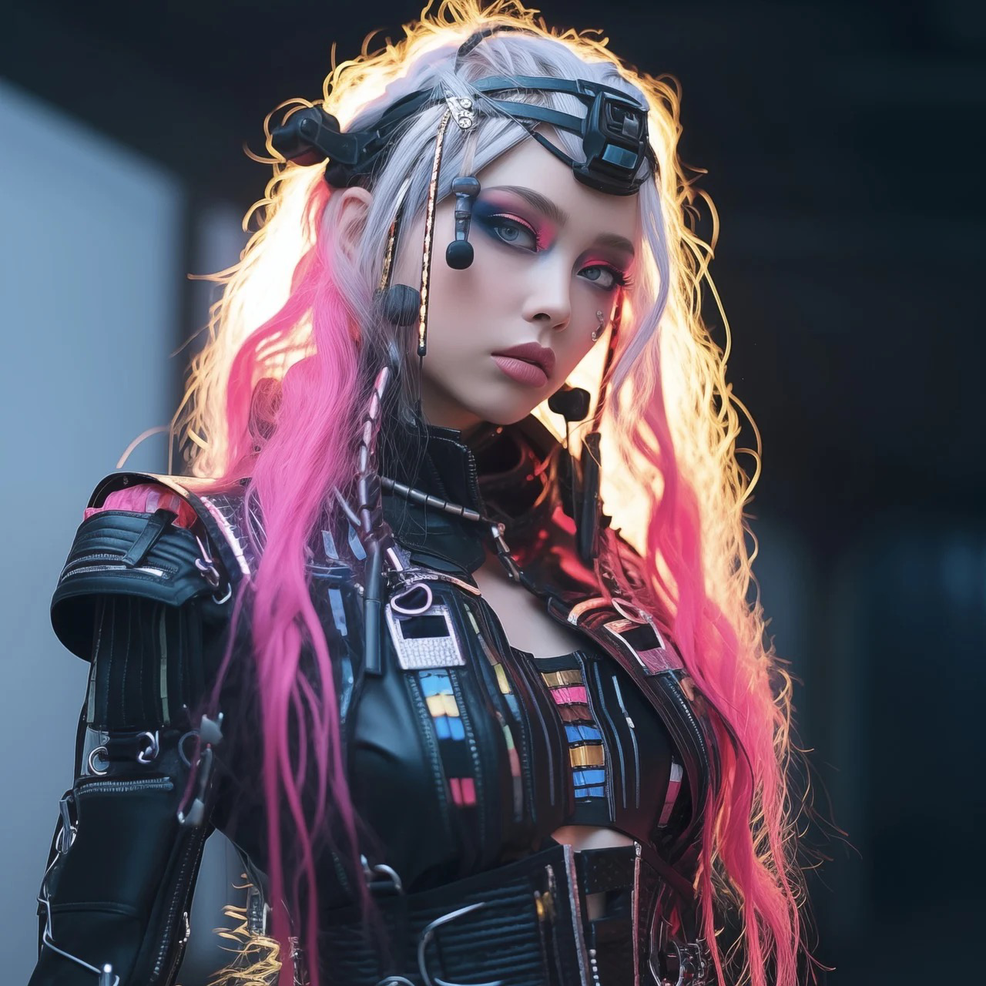
Codename Neko ( real name unknown ) - Neko is a cyborg assistant for NewEra Technologies, a cyber-pharmaceutical company that dabbles in nefarious practices. Her pseudo-friendly disposition and perceived innocence can disarm even the toughest. But don't let her youthful innocence fool you, Neko is cunning and infatuated with Mizako.

(The above images are free for use, and taken off pixabay)

The last thing Mizako remembers is something heavy landing on his head.
MIZAKO
(slowly opening his eyes and looking around confused)
Mizako finds himself on the floor and tries to prop himself up on his elbows. He feels sharp pain on the top of his head and reaches for the offending spot.
Neko is sitting on the floor in a dim corner of the room. Her face remains in the shadows.
NEKO

Oh Good! FINALLY! You're alive! At least I don't have to suffer on my own here.
MIZAKO
(turning to look in the direction of the sound, wincing in pain)

Huh? Who...
NEKO

That's one nasty gash you got there, by the way.
MIZAKO
(realizing whose voice it is)

As if you care…
NEKO

Well, Mr. "I'm a gentleman, I'd never get you in trouble." You got me into this mess. The least I expect is for you to get me outta here.
You can croak on your own time.
MIZAKO
(To himself)

Wow…Friendly...
Mizako finally gets off the floor, slightly limping and proceeds to inspect their confinements.
NEKO

You're limping too? Noo... Please, don't die.
MIZAKO

I'm fine. Last time I checked, nobody died from limping.
NEKO
Yet.

MIZAKO

Right... You could perhaps help me find a way out of here?
Failing to find anything of use, Mizako attempts to push the door open by sheer force.
NEKO

Don't bother. Your muscles ( as gorgeous as they may be) are no match here.
MIZAKO
(Frustrated)

Look, I get it. I'm truly sorry I dragged you into my personal little crusade. I promise, once we get out of here you won't see me again, okay?
NEKO
(giggling)

Oh my god. You're so gullible, it's actually hilarious.
MIZAKO
(flabbergasted)

What now? Did I say something funny?
NEKO

You honestly think I'd be here if I didn't want to? You really are as naive as they say. Walk straight into a lion's den without telling a soul. No backup. No nothing. Zilch.
MIZAKO

Whoa. That escalated quickly. A minute ago you didn't want me to die. Now you're saying , this was all a set-up?
I don't know what games you're playing here, Miss, but somebody will be looking for me.

NEKO

Like who? Rohei? Haha.. My sweet boy, there's something you should know about your good, old Rohei.
Rohei spends his days off in a drunken stupor wishing he was dead...like his daughter.
MIZAKO

...d..daughter? He had a daughter?
Wait…how…?
Hey, I’m actually your senior. I’d appreciate some respect.
NEKO
( finally getting to her feet, frustrated and ignoring Mizako )

Anyway...I'm getting bored. I thought you'd put up a fight or something. Guess you got hit on the head pretty hard.
Ugh...gotta do everything myself around here.
Neko walks over to Mizako, who's standing by the door and caresses his cheek. Caught off guard, Mizako freezes, then gently swats her hand away.
MIZAKO
Come on, cut it out..
NEKO
( sighing…)
Whatever…Let's get out here before you pass out.

Neko applies all of her strength on the door making it budge slowly, before it opens just enough for them to slip through.
NEKO
( casually quipping while showing off her bionically enhanced arms)

Cybertech rules...
MIZAKO
( in disbelief)

You...could've let us out all along?
(pause)

Listen, little lady…Why did you have me trapped here?
NEKO

Hmm... no reason. Just testing the waters...
MIZAKO

Testing the waters…Well, that’s nice. Thank you for wasting my time and bestowing this absolutely useless information on me.
What do you want from me?
NEKO
( gesturing to Mizako to get a move on it )

I don't know yet.
Come on, off you go now, before somebody notices. You're walking like an amoeba, Jesus.
Chop chop.
Neko watches with a subtle smirk as Mizako reluctantly limps towards the exit.

NEKO
( half smirking )
Until next time…
Trigger / Bark List

Original Mission Brief
Design have just made a playable build for a mission where our main character is attacked by three waves of zombies, each wave increases with difficulty. The Zombies are most vulnerable from behind where our hero's sword is effective but the hero's fire spell won't cause any damage. If the main character is bitten, they have thirty seconds to find and drink a tonic to rid themselves of infection or they die. The tonics appear as additional loot when a Zombie is downed.
Reimagined Brief
The detective duo find themselves in a bit of a jam, when they are suddenly attacked by hordes of humanoid robots with mind-altering abilities. The robots appear in three waves, and are most vulnerable from behind since they are unable to use their power if a target is not within their field of vision. Mizako has an EMP gun and Rohei is armed with his trusty, old-school revolver with an unlimited number of bullets. He's also a situational smoker, hence always carries a pack of cigs. If a robot get to use their mind-altering powers on them, they have 30 seconds to find a syringe with an antidote. When a robot is 'deactivated', they drop a couple of syringes each.

String ID | Dialogue | Speaker | Trigger Type | VO Direction
TEXT_MIZAKO_WAVE01_APPROACH_LINE1 | Whoa! What's that? | Mizako | seeing approaching enemy | mildly surprised, mostly in disbelief
TEXT_MIZAKO_WAVE01_APPROACH_LINE2 | Cyborgs? | Mizako | seeing approaching enemy | surprised
TEXT_ROHEI_WAVE01_APPROACH_LINE1 | Right on schedule ... | Rohei | seeing approaching enemy | expecting some kind of an attack or resistance
TEXT_ROHEI_WAVE01_APPROACH_LINE2 | Come to granpa. Don't be shy now. | Rohei | seeing approaching enemy | calm and collected
TEXT_MIZAKO_WAVE02_APPROACH_LINE1 | They're coming back! | Mizako | seeing approaching enemy | unnerved somewhat
TEXT_MIZAKO_WAVE02_APPROACH_LINE2 | Shit! There's tons of them! | Mizako | seeing approaching enemy | slowly panicking
TEXT_ROHEI_WAVE02_APPROACH_LINE1 | You want more?! | Rohei | seeing approaching enemy | calm and somewhat arrogant
TEXT_ROHEI_WAVE02_APPROACH_LINE2 | Can't wait to die, I see. | Rohei | seeing approaching enemy | irked
TEXT_MIZAKO_WAVE03_APPROACH_LINE1 | If this is it, I'll go out in a blaze of glory. | Mizako | seeing approaching enemy | false bravado
TEXT_MIZAKO_WAVE03_APPROACH_LINE2 | We're doomed! | Mizako | seeing approaching enemy | panicking
TEXT_ROHEI_WAVE03_APPROACH_LINE1 | Oh, you're persistent fuckers. Gotta give you that. | Rohei | seeing approaching enemy | irritated
TEXT_ROHEI_WAVE03_APPROACH_LINE2 | Let's finish this! | Rohei | seeing approaching enemy | getting pissed
TEXT_MIZAKO_HEALTH_LOW_LINE1 | They got me. | Mizako | mind control imminent | succumbing to the effects of mind control
TEXT_MIZAKO_HEALTH_LOW_LINE2 | Who am I? | Mizako | mind control imminent | succumbing to the effects of mind control
TEXT_ROHEI_HEALTH_LOW_LINE1 | No, No..you...will.. not..have..me. | Rohei | mind control imminent | laboured breathing
TEXT_ROHEI_HEALTH_LOW_LINE2 | You...will.. not ...take... me... alive... | Rohei | mind control imminent | defiant, succumbing to the effects of mind control
TEXT_MIZAKO_GIVING_DAMAGE_LINE1 | Woohoo! Got one! | Mizako | cyborg down | ecstatic
TEXT_MIZAKO_GIVING_DAMAGE_LINE2 | Not so tough now, are we? | Mizako | cyborg down | satisfied
TEXT_ROHEI_GIVING_DAMAGE_LINE1 | Take that, you fugly piece of scrap metal. | Rohei | cyborg down | satisfied
TEXT_ROHEI_GIVING_DAMAGE_LINE2 | Negotiating is not my forte. | Rohei | cyborg down | satisfied
TEXT_MIZAKO_TAKING_DAMAGE_LINE1 | I...can't think straight. | Mizako | health is deteriorating | confused
TEXT_MIZAKO_TAKING_DAMAGE_LINE2 | I can't hold'em off much longer. | Mizako | health is deteriorating | confused
TEXT_ROHEI_TAKING_DAMAGE_LINE1 | Is that all you got, fuckers? | Rohei | health is deteriorating | defiant
TEXT_ROHEI_TAKING_DAMAGE_LINE2 | Annoying fuck! Get out of my head! | Rohei | health is deteriorating | defiant
TEXT_MIZAKO_IDLE_PROMPT_LINE1 | We gotta move. | Mizako | idle state | impatient
TEXT_MIZAKO_IDLE_PROMPT_LINE2 | Crimes won't get solved by themselves. | Mizako | idle state | impatient
TEXT_ROHEI_IDLE_PROMPT_LINE1 | Todaaay would be real nice... | Rohei | idle state | bored
TEXT_ROHEI_IDLE_PROMPT_LINE2 | You're taking the piss, aren't ya? | Rohei | idle state | so over it
TEXT_MIZAKO_ANTIDOTE_USED_LINE1 | Good as new. | Mizako | health is replenished | satisfied
TEXT_MIZAKO_ANTIDOTE_USED_LINE2 | Myself again. | Mizako | health is replenished | satisfied
TEXT_ROHEI_ANTIDOTE_USED_LINE1 | Ahh...all you need is a clear mind. | Rohei | health is replenished | satisfied
TEXT_ROHEI_ANTIDOTE_USED_LINE2 | Back to my old, jaded self. All good. | Rohei | health is replenished | satisfied
TEXT_MIZAKO_ANTIDOTE_COLLECTED_LINE1 | Will come in handy. | Mizako | reward | satisfied
TEXT_MIZAKO_ANTIDOTE_COLLECTED_LINE2 | Good-to-haves for the road. | Mizako | reward | satisfied
TEXT_ROHEI_ANTIDOTE_COLLECTED_LINE1 | One more for my stash. | Rohei | reward | satisfied
TEXT_ROHEI_ANTIDOTE_COLLECTED_LINE2 | There can never be too much of this. | Rohei | reward | satisfied
TEXT_MIZAKO_ATTACK_END_LINE1 | Whew.. That was intense! | Mizako | attack is over | accomplished
TEXT_MIZAKO_ATTACK_END_LINE2 | Oh man, I lived. | Mizako | attack is over | accomplished
TEXT_ROHEI_ATTACK_END_LINE1 | That's it? Weak...by any standards. | Rohei | attack is over | accomplished
TEXT_ROHEI_ATTACK_END_LINE2 | Disappointing, I tell ya. Like fighting hamsters on steroids. | Rohei | attack is over | accomplished

